**CS2S567 Professional Practice and Employability:**

**Team Based Software Development Workshop**

**Team**

**Portfolio**

**Phase 2**

|  |  |  |  |
| --- | --- | --- | --- |
| Team Number | **6** | | |
| Team Task | Company Asset Tracking | | |
| Own role(s) and tasks in Team |  | Tasks | |
| Brendon Plummer  (18077552) | * Wrote Vulnerability Document |  |
| Chloe Andronicou  (30014005) | * Seminar creation * Wrote Vulnerability Document |
| Jack Lee Davies  (30001575) | * Wrote Vulnerability Document * Seminar creation |
| Jennifer Whewell  (30002739) | * Seminar Creating * Wrote Vulnerability Document |
| Saidhbh O’Malley  (30007730) | * Wrote Vulnerability Document |

|  |  |
| --- | --- |
| Weeks 13 & 14 | Project Setup |
| Author: Jenni | **Team** |
| Activities undertaken | **Week 13:**  This was the week after the submission for phase 1 of the group and individual portfolio, so we had a meeting to discover what was entailed in phase 2 of the project. Shaily informed us that for phase 2 of the project we would be creating a seminar based on several topics.  In this meeting we discussed what subjects we were going to focus on for the phase 2 seminar. It was decided that the topic would be testing, hacking and git hub.  In the tutorial for Professionalism this week, we asked Shaily questions based on SQLite.  **Week 14:**  The structure of this week’s meeting was based around the vulnerabilities of coding and how it can affect code if it is exposed to these vulnerabilities. As a group we decided that we were all going to create an essay based on two vulnerabilities that Shaily had given out. The structure of the vulnerability document and who is tackling what vulnerability can be seen below:  Vulnerability Document:  What it is  How can it affect code?  How to prevent it  Who has what vulnerability:   * Jenni: SQL Injection and Missing authentication and authorization * Jack: Missing data encryption and unprotected storage and credentials * Chloe: Integer Overflow and tainted data * Saidhbh: Buffer overflow and firmware * Brendon: OS command injection and invalidated input   In the same meeting, we discussed the seminar title. Jenni, Jack, and Chloe volunteered to do the seminar and split up the seminar into three section. I decided that to cover hacking, Chloe chose testing and Jack chose GitHub. As a group, we plan to have the seminar completed by week 16 with the voice overs added. |
| Outcome of QA activities | **Week 13:**  Start to have a better understanding of connecting a database to Python using SQLite.  **Week 14:**  Each team member was assigned two vulnerabilities to be completed by the 26th of February. Reviewing it next week.  The seminar was split into three topics. All being assigned to Jenni, Jack, and Chloe. |
| Activities resulting from QA process | **Week 13:**  Phase 2 of the project had started  Our Seminar had been assigned to us with the topics.  **Week 14:**  Vulnerability document started, with 2 titles being assigned to each team member. |
| Evidence of own activities | See Additional Evidence |

Evidence of Seminar assignment:

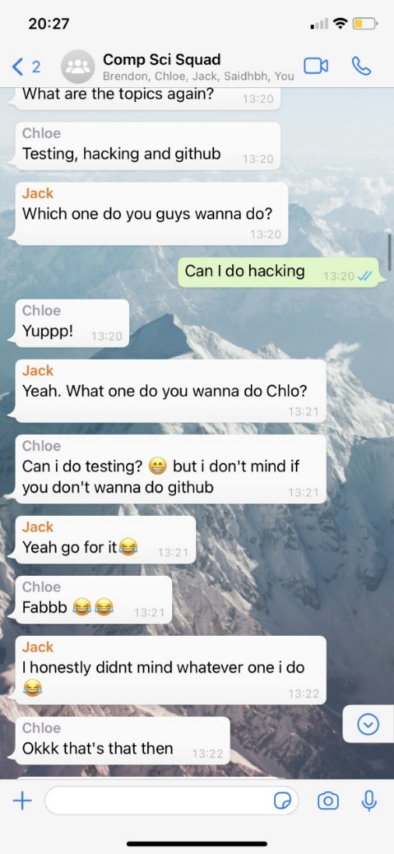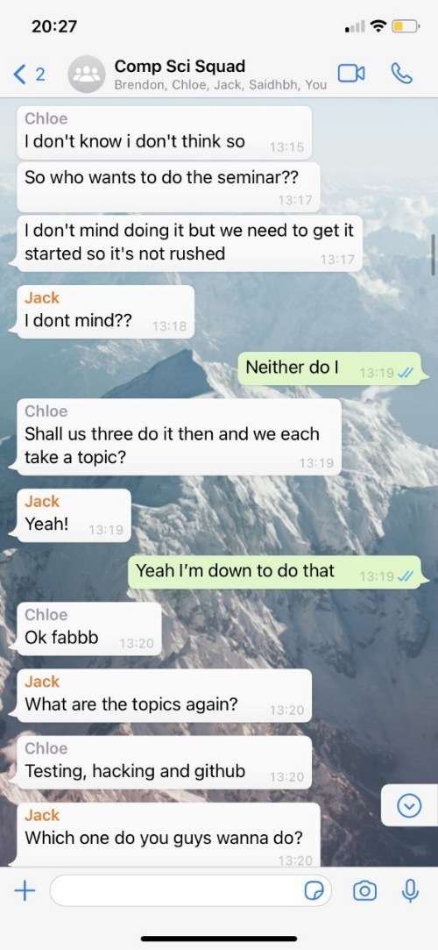

|  |  |
| --- | --- |
| Weeks 15 & 16 | Project Setup |
| Author: Jenni | **Team** |
| Activities undertaken | **Week 15:**  We discussed the progress that each team member had made with their tasks:  Each team member had finished their first vulnerability and shared this to Trello for each member to compare on the similarities and structure of the essay.  The vulnerabilities that each team member needed to work on for the next couple of weeks were:   * Jenni: Missing authentication and authorization * Jack: Unprotected storage and credentials * Chloe: Tainted data * Saidhbh: Firmware * Brendon: Invalidated input   However, we all made an agreement that we wanted to revisit referencing. To do so, we will use the study skills page on the USW site which tells you exactly how to do so.  The site we will be using to reference our sites can be found below:  [Referencing | University of South Wales](https://studyskills.southwales.ac.uk/academic-skills/referencing/)  By the end of the week, Jenni (myself), Jack, and Chloe had started the seminar and were researching the different topics in depth to portray on the PowerPoint.  Continuation of the programming project was still the main point of the meeting, with each team member still expanding their knowledge and skills of Python.  **Week 16:**  We began this meeting by discussing the progress of the seminar - Jenni (myself), Jack, and Chloe attended. We all managed to finish the seminar within a week of starting it, which meant that we could all review and improve on the seminar a long time before it was due and was not rushed.  With the meeting being on a Wednesday, we wanted all the voice-overs done for the seminar by Thursday so we could ensure that the timing of the voice-overs flowed and there were no errors on either end. Each team member was assigned an equal number of slides each.  As part of the professionalism and employability module, we must give feedback to all the other seminars, for which we did so in this meeting. The consensus for the other groups were all excellent and we were impressed with how every team adapted and improved on their seminars from phase 1.  As part of our feedback for phase 1 of the project, the general feedback was that we need to utilize GitHub. For this to be met to achieve higher grades, we uploaded all the work we have completed up until this point to the repository and will continue to use this to track progress of all team members throughout the week. |
| Outcome of QA activities | **Week 15:**  Working through the next vulnerabilities assigned to us, completion of the references is still needed for the document to fit the requirements of the marking scheme.  **Week 16:**  The slides for the seminar were split up for the appropriate team members with each team member given the opportunity to do research on the topics and annotate the slides accordingly.  Completion of feedback for different teams were completed, giving us as a group to self-reflect on the work we have produced.  Upload all work completed so far to GitHub to explore and broaden our knowledge of how the repository works with accordance to the coding we have designed so far for the project. |
| Activities resulting from QA process | **Week 15:**  Complete the second vulnerability by the 26th of February.  Start work on the seminar.  Research and complete referencing for the vulnerability documents.  **Week 16:**  Complete all annotations for the seminar by Thursday for submission on Monday.  All feedback for other groups completed.  Add all work completed so far to the GitHub repository. |
| Evidence of own activities | See Additional Evidence:  **Evidence of planning a meeting for seminar:** |